SPRING Program University of Toyama Application Category Check Sheet
2026 Extra Round
（#Form2）

This checklist is used to confirm the application category for the SPRING program. Please review the flowchart below, check the applicable items, and confirm your application category (also indicate it in the “Application Category” section of the application form). Additionally, please submit this checklist together with the application form as an email attachment.
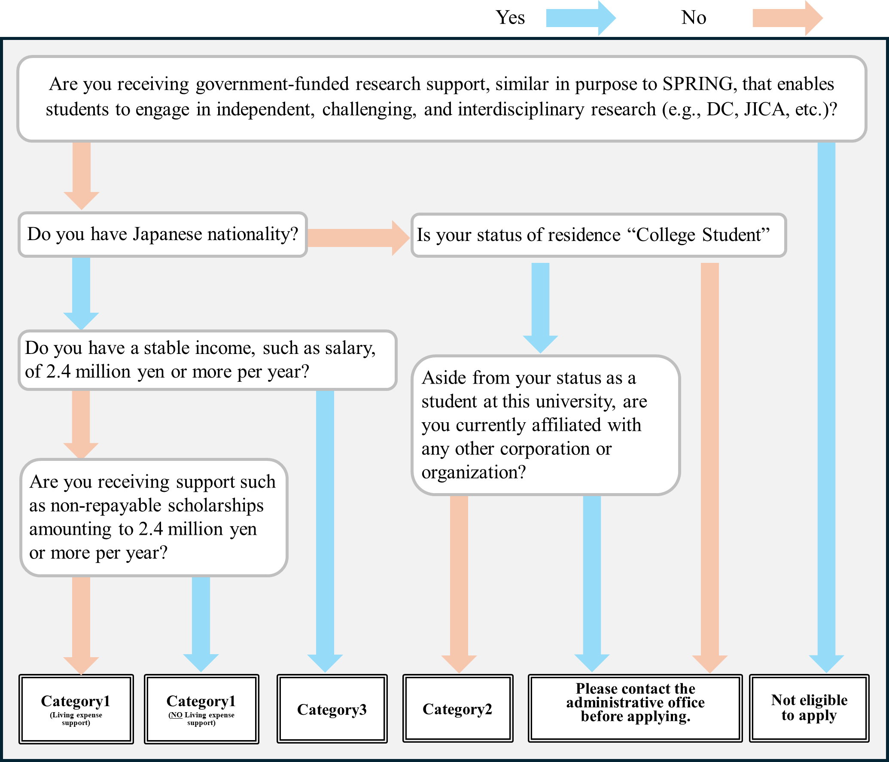

☐Yes
☐No
☐No

☐No
☐Yes
☐Yes

☐No
☐Yes

☐Yes
☐No
☐Yes
☐No

Category | Select from the list | Name

※Please enter the result (category) obtained from the flowchart and your name.

Name of scholarship(s), etc.
Scholarship Status | Select from the list | Monthly stipend | JPY
Period of scholarship receipt (planned) | MM/YYYY - MM/YYYY
※If you are currently receiving, planning to receive, or have applied for a non-repayable scholarship or similar financial support, please provide the details.

